A000-US-SD-Lakota-Shaman's Gourd shaped rattle 1790's to 1840's .

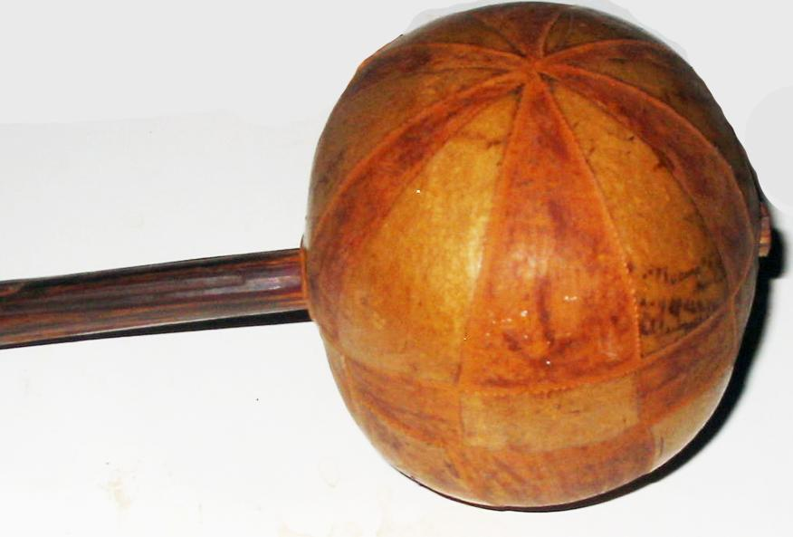

Value $4,000

**Case No.: 12**

**Accession No.**

**Formal Label:**

**Display Description:**

Shaman's Gourd shaped rattle late 18th to early 19th century. Dates from 1790's to 1840's .  
Two parts carved wood in a melon-form rattle. Rare and in the condition it's in could easily can be placed in a museum's collection. This rare gourd-shaped rattle shows the tripartite universe: upper world, middle world and underworld and provides the imagery and symbolism essential to the shaman’s flight to ascend to the upper world or descend into the lower world. It provides the rhythm that is essential to entering into this deep meditation.

**LC Classification:**

**Date or Time Horizon:** 1790's to 1840's .

**Geographical Area:**

**Map:**

**GPS coordinates:**

**Cultural Affiliation:**

**Media:**

**Dimensions:**

**Weight:**

**Condition:**

**Provenance:**

**Discussion:**

**References:**

